BANYAN TREE SCHOOL,

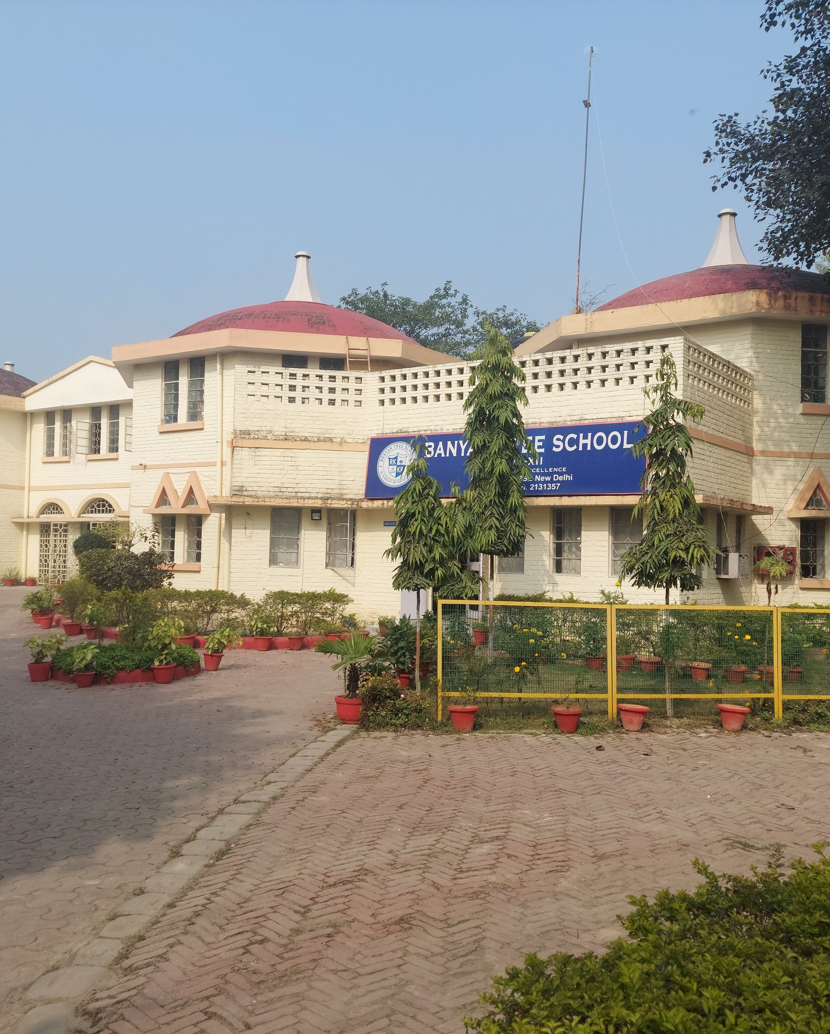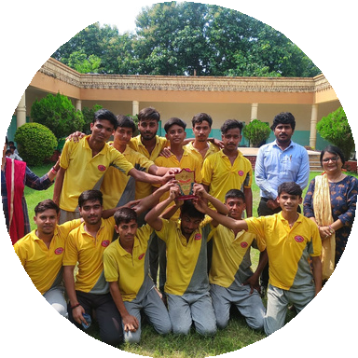

JAGDISHPUR

2025

**CLASS - X**

gdfgkjgkl;

|  |  |
| --- | --- |
| **English** | **PORTFOLIO: PREPARE A PORTFOLIO WITH THE FOLLOWING** –(Prepare a file with A4 size sheets)  Introduction My strengths , I need to improve on, My achievements, I have  participated in, The books I have read, The book I wish to read  **Poster Making (A-4 size sheet):**  Make a poster portraying your thoughts and point of view on: “Love for freedom is the natural instinct of every living being.” You may read Leslie Norris’s A Tiger in the Zoo for your reference. |
| **Hindi** | Make a portfolio of authors or poets as discussed in the class.  For reference use the given link - |
| **Mathematics** | **Links for Model work.**  Topic-1 :- Working model on real numbers.  <https://youtu.be/dUODEweinYs?si=LEXog3pDzCpKYecU>  Topic-2 :- working model on trigonometry park  <https://youtu.be/UG64u15EtLY?si=JdCe_3LGKcP9No_x> |
| **SCIENCE** | **BIOLOGY**  **Experiment**  * To show that carbon dioxide is necessary for photosynthesis.  *To show that chlorophyll is necessary for photosynthesis.  * Preparation of temporary Mount of leaf peel to show stomata.  * Experimentally show that, carbon dioxide is given out during respiration.  **Project work**  Make a model of digestive system with the help of different colours clay on a sheet.  **PHYSICS**  For even roll no. students : - Make a beautiful chart showing types of mirror and their  ray diagrams using colored pen  For odd roll no. students : - Make a simple periscope using two plane mirrors and a cardboard box.  **CHEMISTRY**  **Prepare any one of the following on a chart paper:**  *A flowchart of types of chemical reactions with balanced examples.  Home-Based Experiments (Simple & Safe)  **Experiment 1**: Reaction of Baking Soda with Lemon Juice  **Materials:** Lemon juice, baking soda, bowls.  **Observe the fizzing** — write the reaction and explain the observation.  Chemical equation involved: Write and balance it. |
| **IT** | Collect the images of all of your family members and make a presentation on their  specialty and stress management skill using transition, animation, speech text and  other styling feature as per your requirement.  NOTES: Take out the coloured print out of all the slides and prepare a portfolio  by arranging it in a transparent file. |
| **SST** | **PROJECT (Choose any one topic from the given list.)**  **1.**  Consumer Rights and Awareness **2.** Social Issues and Citizenship  **3.** Sustainable Development **4.**Elections and Political Parties.  **5.** Emerging Role of the Tertiary Sector in India **6.** Forest and Wildlife  **7.** Self Help Group **8.**Human Development Index **9.** Nationalism in India |

