BANYAN TREE SCHOOL,

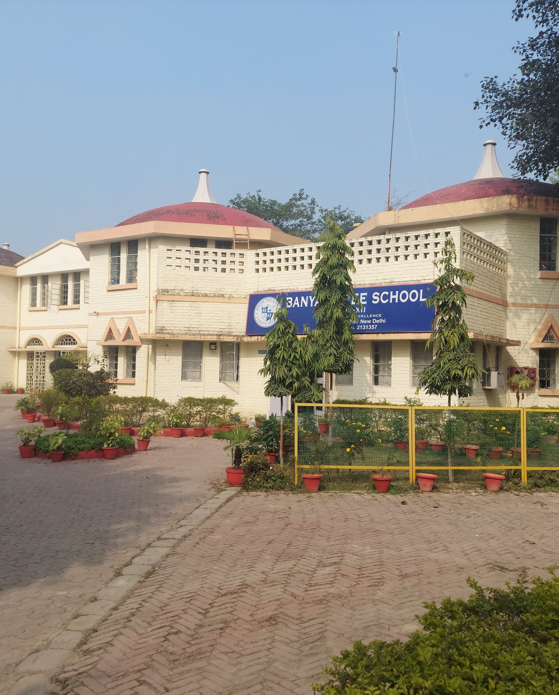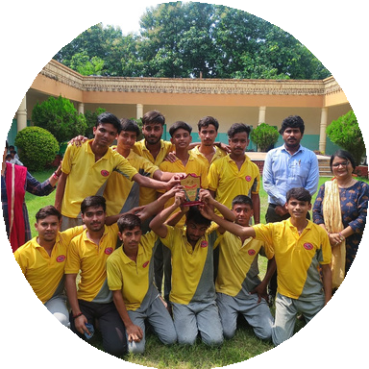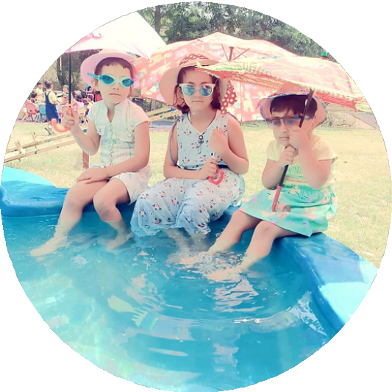

JAGDISHPUR

2025

**CLASS - IX**

gdfgkjgkl;

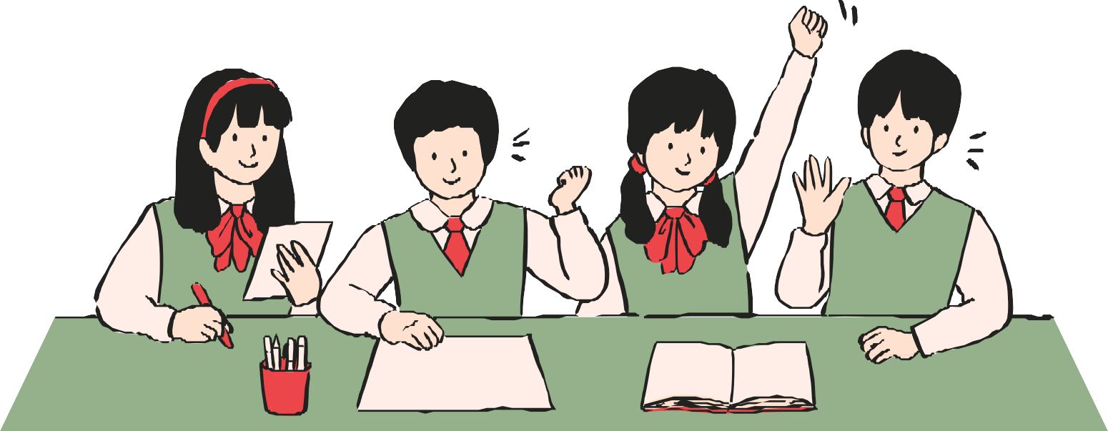

|  |  |
| --- | --- |
| English | WRITING: 1. Summarize the poems Rain on the Roof and Wind you read in your  own words, find out the poetic devices used in the poem.  2. Write the Answers to the questions given in ADVENTURES OF TOTO in your notebook.  3. Prepare a note of 5 HEADLINES (only positive news) from any ENGLISH NEWSPAPER for  15 days and write the new words with their meanings and make 1 sentence from each word.  4. Prepare a TENSE CHART with proper sentence structure and examples.  5. Write a diary entry about a memorable experience from your summer vacation and the  new things you tried or learnt recently  C. LISTENING: 1. Listen to the English news channels daily for preparing HEADLINES  D. SPEAKING: Prepare a speech on “My Vision For India”. |
| Hindi | 1. मुन्शी प्रेम चन्द तथा महादेवी वर्मा का संक्षिप्त जीवन परिचय लिखिए एवं उनकी रचनाओ की  सूची बनाइए।  2. जल संरक्षण के लिए भारत सरकार द्वारा किए जा रहे प्रयासो का उल्लेख कीजिए।  3. बिजली का दुरुपयोग बचाने के लिए मित्र को सुझाव देते हुए पत्र लिखिए।  4. ग्रीष्म ऋतु मे आप जहां भी घूमने जाए वहां का यात्रा वृतांत लिखिए। |
| Mathematics | 1. Prepare your portfolio in Mathematics on chapters:  1- Number System 2- Polynomials, as discussed in the class.  2. Frame 10 polynomials each which have following factors:-  i) x-1 ii) x+1 iii) x-2 iv) x+2 3.  Apply factor theorem to verify the situation in the above problem.  4. Explore at least five real life situations where you get linear equation. Why the linear  equations in one variable have unique solution?  5. Write five terminating type and five non terminating-repeating type of decimal number.  Represent these numbers in p/q form. Which kind of prime factors of the denominators are  Obtained in both the cases? Note down the conclusion drawn in each case.  6. Complete the given assignments and submit on the reopening of school after summer  vacation. |
| SCIENCE | **BIOLOGY**  Write these experiments properly in the experiment file.  1-To prepare temporary stained Mount of onion peel to study epidermal cells.  2- To prepare a temporary mount of human cheek cells and observe under a microscope.  **Research work**  Find out the different types of cell divisions, draw pictures of the different stages.  In project file.  **PHYSICS:**  **Topic -Motion( Activity 1) Draw the following on the graph paper and bring it in transparent**  **file.**  1. Distance time graph for uniform and non-uniform motion.  2. Velocity time graph for uniform velocity.  3. Velocity time graph for uniform acceleration. |

|  |  |
| --- | --- |
|  | **Activity 2. In your everyday life you come across a range of motions in which**  (a) Acceleration is in the direction of motion.  (b) Acceleration is against the direction of motion.  (c) Acceleration is uniform.  (d) Acceleration is non-uniform.  Can you identify one example each of the above type of motion?  **CHEMISTRY**  Activity  Make a chart or poster on any one topic (choose from either chapter):  “**States of Matter and Their Properties**”  “**Methods of Separation of Mixtures**”  “**Types of Mixtures: Homogeneous vs. Heterogeneous**”  Use pictures, real-life examples, and short definitions. Be creative and neat. |
| IT | 1-Make a presentation on some common body language errors that one should avoid while  communicating.  2- Make a project on significance of visual communication.  3-Think of a goal you want to achieve. Apply the SMART strategy to develop a plan for  achieving it. Track your progress. After achieving your goal, record what self management  principles you employed and how they help you. Do a write -up on your experience and your  learning from the entire process. |
| SST | **ECONOMICS Activity: [NCERT Book Page No. 19]**  1. Visit a nearby village or a slum area and write down a case study of a boy or  girl of your age facing the same condition as Vilas or Sakal.  OR  **Project :** SARVA SHIKSHA ABHIYAN  **Activity: [NCERT Book Page No. 13] - HISTORY**  1. Identify the symbols in Box 1 which stand for liberty, equality and fraternity.  2. Explain the meaning of the painting of the Declaration of Rights of Man and Citizen  (Fig 8) by reading only the symbols.  3. Compare the political rights which the Constitution of 1971 gave to the citizens with  Articles 1 and 6 of the Declaration (Source C).Are the two documents consistent?  Do the two documents convey the same idea? |

