Banyan Tree school, Jagdishpur
Holiday Homework for Summer Break
Class – Nursery
E. V. S –
1. Learn and paste the name of fruits and vegetables.
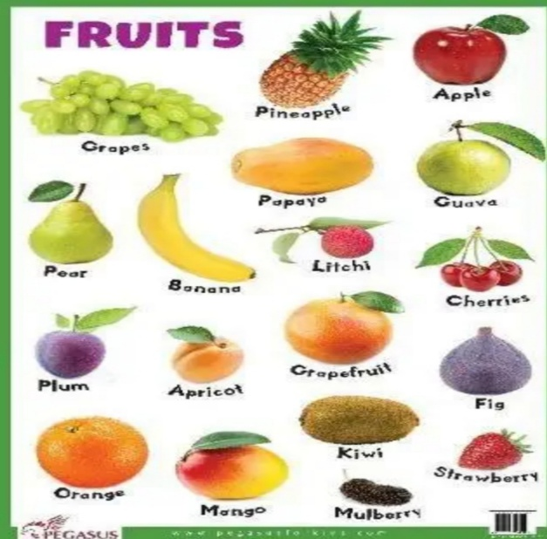
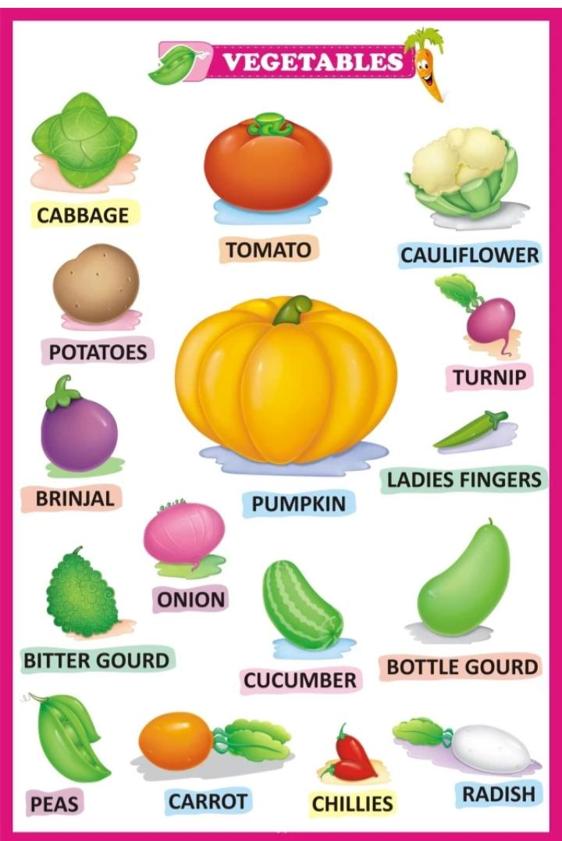

2.Learn the name of body parts.
3.Learn these sentences -
- My name is ___________
- My father’s name is _____________.
- My mother’s name is ______________
- I study in class nursery.
- I live in ________.

Maths-
- Oral counting 1 to 20
- Do practice of 1 to 20 in your maths notebook.
Hindi –
- अ से अः तक याद करे |
- कविता याद करे – आलू काचालू
English –
- Learn A to Z.
- Do practice of A to Z in your English notebook.
- Learn the poem ‘Bits of paper ‘and ‘Clap your hands’.
Craft –
- Make a rabbit with the use of papers.
- Make a Chinese paper lantern.

